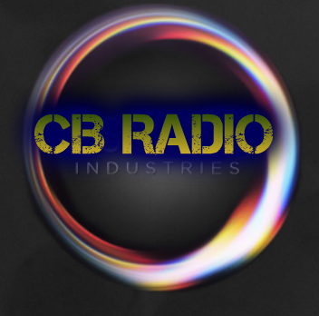 CB Radio® Industries
Founded: 2014
CEO: Alexander A Zdanowicz
URL: http://www.cbhits.weebly.com/

Services: Radio Streaming, Website education, live events, and motivational speeches.
Hi and welcome to CB Hits™, the only place where you can listen and download music for FREE! Our goal is to provide to the public a five star radio station that you will enjoy. Unlike other stations out there, CB Radio® is proven to be the world’s #1 radio station. Have Fun and Enjoy.

Sincerely,
Alexander A Zdanowicz, Founder and CEO of CB Radio®.

